Tcl script to create fixed wirless nodes
Description:
Three wireless nodes are created and they are configured with specific parameters of a mobile wireless node. After creating the nam file and trace file, we set up topography object. set node_ ($i) [$ns node] is used to create the nodes. Location of the nodes is fixed by specifying X, Y coordinates. Z coordinate is always zero. Here we set the initial size for the every node by using initial_node_pos. AODV routing protocol is used here. $val(stop) specifies the end time of the simulation.
File name: “wireless1.tcl”
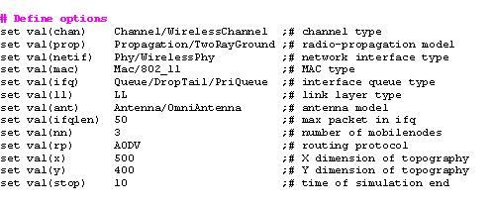
#-------Event scheduler object creation--------#
set ns [new Simulator]
# Creating trace file and nam file
set tracefd [open wireless1.tr w]
set namtrace [open wireless1.nam w]
$ns trace-all $tracefd
$ns namtrace-all-wireless $namtrace $val(x) $val(y)
# set up topography object
set topo [new Topography]
$topo load_flatgrid $val(x) $val(y)
set god_ [create-god $val(nn)]
# configure the nodes
$ns node-config -adhocRouting $val(rp) \
-llType $val(ll) \
-macType $val(mac) \
-ifqType $val(ifq) \
-ifqLen $val(ifqlen) \
-antType $val(ant) \
-propType $val(prop) \
-phyType $val(netif) \
-channelType $val(chan) \
-topoInstance $topo \
-agentTrace ON \
-routerTrace ON \
-macTrace OFF \
-movementTrace ON
## Creating node objects...
for {set i 0} {$i < $val(nn) } { incr i } {
set node_($i) [$ns node]
}
for {set i 0} {$i < $val(nn) } {incr i } {
$node_($i) color black
$ns at 0.0 "$node_($i) color black"
}
# Provide initial location of mobile nodes
$node_(0) set X_ 50.0
$node_(0) set Y_ 50.0
$node_(0) set Z_ 0.0
$node_(1) set X_ 200.0
$node_(1) set Y_ 250.0
$node_(1) set Z_ 0.0
$node_(2) set X_ 300.0
$node_(2) set Y_ 300.0
$node_(2) set Z_ 0.0
# Define node initial position in nam
for {set i 0} {$i < $val(nn)} { incr i } {
$ns initial_node_pos $node_($i) 30
}
# Telling nodes when the simulation ends
for {set i 0} {$i < $val(nn) } { incr i } {
$ns at $val(stop) "$node_($i) reset";
}
# Ending nam and the simulation
$ns at $val(stop) "$ns nam-end-wireless $val(stop)"
$ns at $val(stop) "stop"
$ns at 10.01 "puts \"end simulation\"; $ns halt"
#stop procedure:
proc stop {} {
global ns tracefd namtrace
$ns flush-trace
close $tracefd
close $namtrace
exec nam wireless1.nam &
}
$ns run
# How to run the program
$ns wireless1.tcl
# snapshot of the program output
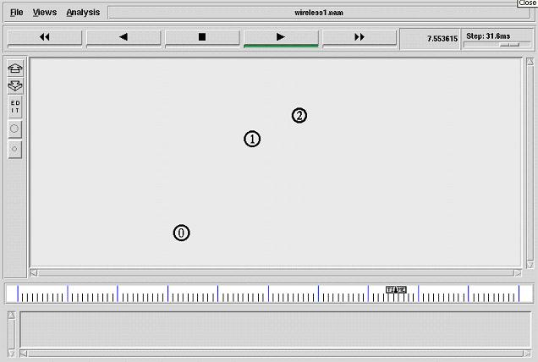

Tcl script to create fixed color wireless nodes
Description:
Eight wireless nodes are created and they are configured with specific parameters of a mobile wireless node. After creating the nam file and trace file, we set up topography object. set node_ ($i) [$ns node] is used to create the nodes. Location of the nodes is fixed by specifying X, Y coordinates. Z coordinate is always zero. Here we set the initial size for the every node by using initial_node_pos. AODV routing protocol is used here. $val(stop) specifies the end time of the simulation. In this program nodes are given with cyan color
File name: “wireless2.tcl”
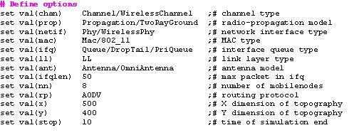
#-------Event scheduler object creation--------#
set ns [new Simulator]
#Creating trace file and nam file.
set tracefd [open wireless2.tr w]
set namtrace [open wireless2.nam w]
$ns trace-all $tracefd
$ns namtrace-all-wireless $namtrace $val(x) $val(y)
# set up topography object
set topo [new Topography]
$topo load_flatgrid $val(x) $val(y)
set god_ [create-god $val(nn)]
# configure the nodes
$ns node-config -adhocRouting $val(rp) \
-llType $val(ll) \
-macType $val(mac) \
-ifqType $val(ifq) \
-ifqLen $val(ifqlen) \
-antType $val(ant) \
-propType $val(prop) \
-phyType $val(netif) \
-channelType $val(chan) \
-topoInstance $topo \
-agentTrace ON \
-routerTrace ON \
-macTrace OFF \
-movementTrace ON
# Creating node objects..
for {set i 0} {$i < $val(nn) } { incr i } {
set node_($i) [$ns node]
}
for {set i 0} {$i < $val(nn) } {incr i } {
$node_($i) color cyan
$ns at 0.0 "$node_($i) color cyan"
}
# Provide initial location of mobilenodes
$node_(0) set X_ 5.0
$node_(0) set Y_ 30.0
$node_(0) set Z_ 0.0
$node_(1) set X_ 50.0
$node_(1) set Y_ 25.0
$node_(1) set Z_ 0.0
$node_(2) set X_ 200.0
$node_(2) set Y_ 90.0
$node_(2) set Z_ 0.0
$node_(3) set X_ 350.0
$node_(3) set Y_ 160.0
$node_(3) set Z_ 0.0
$node_(4) set X_ 100.0
$node_(4) set Y_ 250.0
$node_(4) set Z_ 0.0
$node_(5) set X_ 300.0
$node_(5) set Y_ 100.0
$node_(5) set Z_ 0.0
$node_(6) set X_ 400.0
$node_(6) set Y_ 350.0
$node_(6) set Z_ 0.0
$node_(7) set X_ 3s50.0
$node_(7) set Y_ 470.0
$node_(7) set Z_ 0.0
# Define node initial position in nam
for {set i 0} {$i < $val(nn)} { incr i } {
# 30 defines the node size for nam
$ns initial_node_pos $node_($i) 30
}
# Telling nodes when the simulation ends
for {set i 0} {$i < $val(nn) } { incr i } {
$ns at $val(stop) "$node_($i) reset";
}
# ending nam and the simulation
$ns at $val(stop) "$ns nam-end-wireless $val(stop)"
$ns at $val(stop) "stop"
$ns at 10.01 "puts \"end simulation\" ; $ns halt"
proc stop {} {
global ns tracefd namtrace
$ns flush-trace
close $tracefd
close $namtrace
exec nam wireless2.nam &
}
$ns run
# How to run the program
$ns wireless2.tcl
# snapshot of the program output
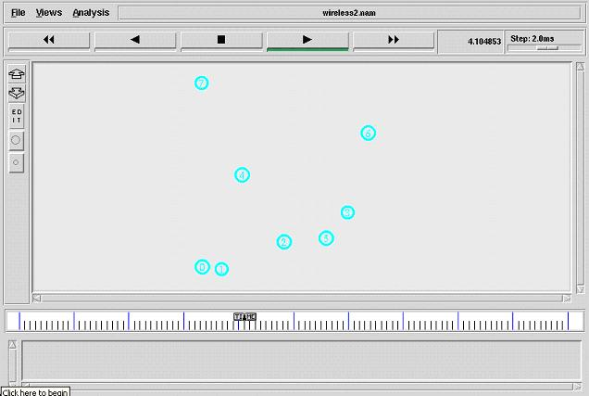

Tcl script to create the dynamic number of nodes
Description:
Number of nodes is not fixed in the program. We can give the number of nodes to be created during runtime. Number of nodes should be given as command line arguments when we run the coding. Dynamically created nodes are configured with specific parameters of a mobile wireless node. After creating the nam file and trace file, we set up topography object. set node_ ($i) [$ns node] is used to create the nodes. Location of the nodes is fixed by specifying X, Y coordinates. Z coordinate is always zero Here we set the initial size for the every node by using initial_node_pos. AODV routing protocol is used here. $val(stop) specifies the end time of the simulation. In this program nodes are given with yellow color.
File name: “wireless1.tcl”
if {$argc != 1} {
error "\nCommand: ns wireless1.tcl <no.of.mobile-nodes>\n\n "
}
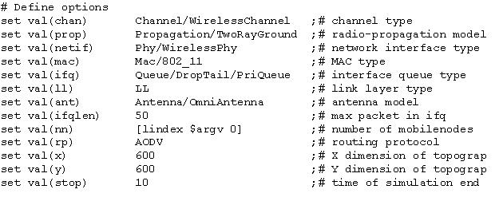
#-------Event scheduler object creation--------#
set ns [new Simulator]
#creating the trace file and nam file
set tracefd [open wireless1.tr w]
set namtrace [open wireless1.nam w]
$ns trace-all $tracefd
$ns namtrace-all-wireless $namtrace $val(x) $val(y)
# set up topography object
set topo [new Topography]
$topo load_flatgrid $val(x) $val(y)
set god_ [create-god $val(nn)]
# configure the nodes
$ns node-config -adhocRouting $val(rp) \
-llType $val(ll) \
-macType $val(mac) \
-ifqType $val(ifq) \
-ifqLen $val(ifqlen) \
-antType $val(ant) \
-propType $val(prop) \
-phyType $val(netif) \
-channelType $val(chan) \
-topoInstance $topo \
-agentTrace ON \
-routerTrace ON \
-macTrace OFF \
-movementTrace ON
## Creating node objects..
for {set i 0} {$i < $val(nn) } { incr i } {
set node_($i) [$ns node]
}
for {set i 0} {$i < $val(nn) } {incr i } {
$node_($i) color yellow
$ns at 0.0 "$node_($i) color yellow"
}
# Provide initial location of mobilenodes
$node_(0) set X_ 27.0
$node_(0) set Y_ 260.0
$node_(0) set Z_ 0.0
$node_(1) set X_ 137.0
$node_(1) set Y_ 348.0
$node_(1) set Z_ 0.0
$node_(2) set X_ 294.0
$node_(2) set Y_ 235.0
$node_(2) set Z_ 0.0
$node_(3) set X_ 414.0
$node_(3) set Y_ 342.0
$node_(3) set Z_ 0.0
$node_(4) set X_ 562.0
$node_(4) set Y_ 267.0
$node_(4) set Z_ 0.0
$node_(5) set X_ 279.0
$node_(5) set Y_ 447.0
$node_(5) set Z_ 0.0
$node_(6) set X_ -128.0
$node_(6) set Y_ 260.0
$node_(6) set Z_ 0.0
$node_(7) set X_ 727.0
$node_(7) set Y_ 269.0
$node_(7) set Z_ 0.0
$node_(8) set X_ 130.0
$node_(8) set Y_ 126.0
$node_(8) set Z_ 0.0
$node_(9) set X_ 318.0
$node_(9) set Y_ 45.0
$node_(9) set Z_ 0.0
$node_(10) set X_ 505.0
$node_(10) set Y_ 446.0
$node_(10) set Z_ 0.0
$node_(11) set X_ 421.0
$node_(11) set Y_ 158.0
$node_(11) set Z_ 0.0

# Define node initial position in nam
for {set i 0} {$i < $val(nn)} { incr i } {
# 30 defines the node size for nam
$ns initial_node_pos $node_($i) 30
}
# Telling nodes when the simulation ends
for {set i 0} {$i < $val(nn) } { incr i } {
$ns at $val(stop) "$node_($i) reset";
}
# ending nam and the simulation
$ns at $val(stop) "$ns nam-end-wireless $val(stop)"
$ns at $val(stop) "stop"
$ns at 10.01 "puts \"end simulation\" ; $ns halt"
proc stop {} {
global ns tracefd namtrace
$ns flush-trace
close $tracefd
close $namtrace
exec nam wireless1.nam &
}
$ns run
# How to run the program
$ns wireless1.tcl
# snapshot of the program output
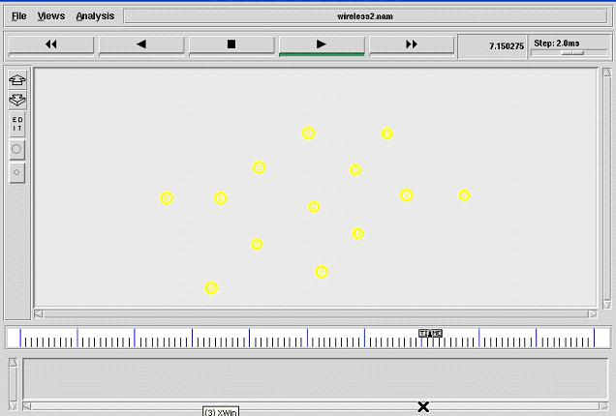

Tcl script to create the dynamic number of nodes and its initial location
Description:
Number of nodes is not fixed in the program. We can give the number of nodes to be created during runtime. Number of nodes should be given as command line arguments when we run the coding. Dynamically created nodes are configured with specific parameters of a mobile wireless node. After creating the nam file and trace file, we set up topography object. set node_ ($i) [$ns node] is used to create the nodes. Initial location of the nodes is not fixed. X, Y coordinates are randomly selected and assigned to every node. Here we set the initial size for the every node by using initial_node_pos. AODV routing protocol is used here. $val(stop) specifies the end time of the simulation. In this program nodes are given with yellow color.
File name: “wireless3.tcl”
if {$argc != 1} {
error "\nCommand: ns wireless3.tcl <no.of.mobile-nodes>\n\n "
}
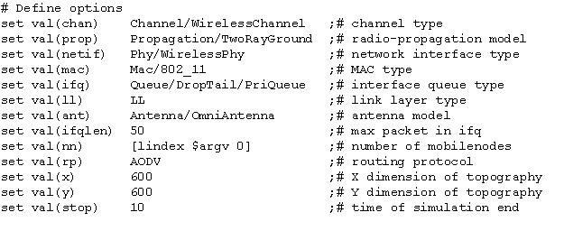
#-------Event scheduler object creation--------#
set ns [new Simulator]
#creating the trace file and nam file
set tracefd [open wireless3.tr w]
set namtrace [open wireless3.nam w]
$ns trace-all $tracefd
$ns namtrace-all-wireless $namtrace $val(x) $val(y)
# set up topography object
set topo [new Topography]
$topo load_flatgrid $val(x) $val(y)
set god_ [create-god $val(nn)]
# configure the nodes
$ns node-config -adhocRouting $val(rp) \
-llType $val(ll) \
-macType $val(mac) \
-ifqType $val(ifq) \
-ifqLen $val(ifqlen) \
-antType $val(ant) \
-propType $val(prop) \
-phyType $val(netif) \
-channelType $val(chan) \
-topoInstance $topo \
-agentTrace ON \
-routerTrace ON \
-macTrace OFF \
-movementTrace ON
## Creating node objects..
for {set i 0} {$i < $val(nn) } { incr i } {
set node_($i) [$ns node]
}
for {set i 0} {$i < $val(nn) } {incr i } {
$node_($i) color gold
$ns at 0.0 "$node_($i) color gold"
}
## Provide initial location of mobilenodes..
for {set i 0} {$i < $val(nn) } { incr i } {
set xx [expr rand()*600]
set yy [expr rand()*600]
$node_($i) set X_ $xx
$node_($i) set Y_ $yy
}
# Define node initial position in nam
for {set i 0} {$i < $val(nn)} { incr i } {
# 30 defines the node size for nam
$ns initial_node_pos $node_($i) 30
}
# Telling nodes when the simulation ends
for {set i 0} {$i < $val(nn) } { incr i } {
$ns at $val(stop) "$node_($i) reset";
}
# ending nam and the simulation
$ns at $val(stop) "$ns nam-end-wireless $val(stop)"
$ns at $val(stop) "stop"
$ns at 10.01 "puts \"end simulation\" ; $ns halt"
#stop procedure...
proc stop {} {
global ns tracefd namtrace
$ns flush-trace
close $tracefd
close $namtrace
exec nam wireless3.nam &
}
$ns run
# How to run the program
$ns wireless3.tcl
# snapshot of the program output
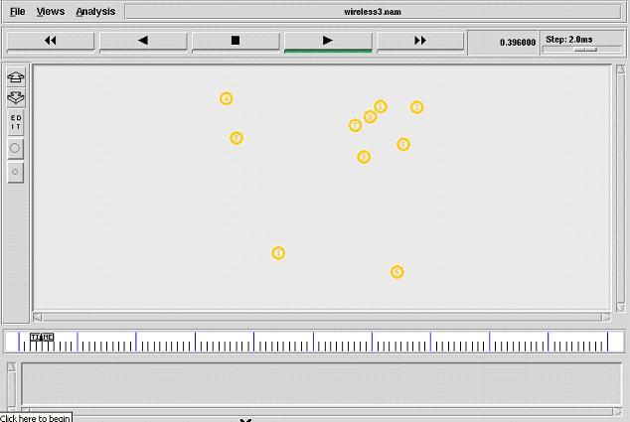

Tcl script to create the dynamic color and initial location to nodes
Description:
Number of nodes is fixed in the program. Nodes are configured with specific parameters of a mobile wireless node. After creating the nam file and trace file, we set up topography object. set node_ ($i) [$ns node] is used to create the nodes. Initial location of the nodes is not fixed. X, Y coordinates are randomly selected and assigned to every node. Here we set the initial size for the every node by using initial_node_pos. AODV routing protocol is used here. $val(stop) specifies the end time of the simulation. In this program nodes are not given color. Their color will change dynamically based on time.
File name: “wireless1.tcl”
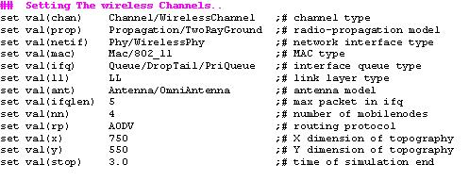
#-------Event scheduler object creation--------#
set ns [new Simulator]
## Create a trace file and nam file..
set tracefd [open wireless1.tr w]
set namtrace [open wireless1.nam w]
## Trace the nam and trace details from the main simulation..
$ns trace-all $tracefd
$ns namtrace-all-wireless $namtrace $val(x) $val(y)
## set up topography object..
set topo [new Topography]
$topo load_flatgrid $val(x) $val(y)
set god_ [create-god $val(nn)]
## Color Descriptions..
$ns color 1 dodgerblue
$ns color 2 blue
$ns color 3 cyan
$ns color 4 green
$ns color 5 yellow
$ns color 6 black
$ns color 7 magenta
$ns color 8 gold
$ns color 9 red
## Array for dynamic color settings...
set colorname(0) blue
set colorname(1) cyan
set colorname(2) green
set colorname(3) red
set colorname(4) gold
set colorname(5) magenta
## Setting The Distance Variables..
# For model 'TwoRayGround'
set dist(5m) 7.69113e-06
set dist(9m) 2.37381e-06
set dist(10m) 1.92278e-06
set dist(11m) 1.58908e-06
set dist(12m) 1.33527e-06
set dist(13m) 1.13774e-06
set dist(25m) 3.07645e-07
set dist(30m) 2.13643e-07
set dist(35m) 1.56962e-07
set dist(40m) 1.56962e-10
set dist(45m) 1.56962e-11
set dist(50m) 1.20174e-13
#Phy/WirelessPhy set CSThresh_ $dist(50m)
#Phy/WirelessPhy set RXThresh_ $dist(50m)
## Setting node config event with set of inputs..
$ns node-config -adhocRouting $val(rp) \
-llType $val(ll) \
-macType $val(mac) \
-ifqType $val(ifq) \
-ifqLen $val(ifqlen) \
-antType $val(ant) \
-propType $val(prop) \
-phyType $val(netif) \
-channelType $val(chan) \
-topoInstance $topo \
-agentTrace ON \
-routerTrace ON \
-macTrace OFF \
-movementTrace ON
## Creating node objects...
for {set i 0} {$i < $val(nn) } { incr i } {
set node_($i) [$ns node]
}
for {set i 0} {$i < $val(nn) } {incr i } {
$node_($i) color blue
$ns at 0.0 "$node_($i) color blue"
}
## Provide initial location of mobilenodes...
for {set i 0} {$i < $val(nn) } { incr i } {
set xx [expr rand()*600]
set yy [expr rand()*500]
$node_($i) set X_ $xx
$node_($i) set Y_ $yy
$node_($i) set Z_ 0.0
}
## Define node initial position in nam...
for {set i 0} {$i < $val(nn)} { incr i } {
# 30 defines the node size for nam..
$ns initial_node_pos $node_($i) 30
}
## Dynamic color procedure..
$ns at 0.0 "dynamic-color"
proc dynamic-color {} {
global ns val node_ colorname
set time 0.3
set now [$ns now]
set Rand [expr round(rand()*5)]
for {set i 0} {$i < $val(nn) } {incr i } {
$node_($i) color $colorname($Rand)
$ns at $now "$node_($i) color $colorname($Rand)"
}
$ns at [expr $now+$time] "dynamic-color"
}
## stop procedure..
$ns at $val(stop) "stop"
proc stop {} {
global ns tracefd namtrace
$ns flush-trace
close $tracefd
close $namtrace
puts "running nam..."
exec nam wireless1.nam &
exit 0
}
$ns runs
#how to run this program...
$ns wireless1.tcl
# snapshot of the program:
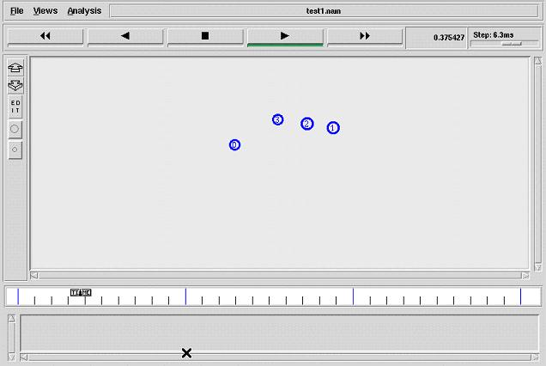
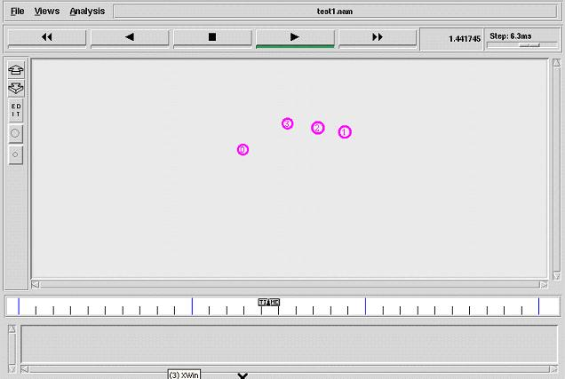

Tcl script to give mobility to nodes
Description:
Number of nodes is fixed in the program. Nodes are configured with specific parameters of a mobile wireless node. After creating the nam file and trace file, we set up topography object. set node_ ($i) [$ns node] is used to create the nodes. Initial location of the nodes is fixed. Specific X, Y coordinates are assigned to every node. Nodes are given mobility with fixed speed and specific destination location which is generated randomly. Nodes’ mobility will change time to time. Here we set the initial size for the every node by using initial_node_pos. AODV routing protocol is used here. $val(stop) specifies the end time of the simulation.
File name: “wireless3.tcl”
if {$argc != 1} {
error "\nCommand: ns test2.tcl <no.of.mobile-nodes>\n\n "
}
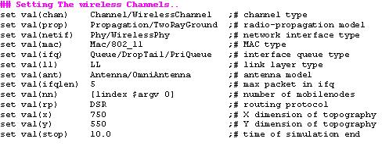
#-------Event scheduler object creation--------#
set ns [new Simulator]
## Create a trace file and nam file..
set tracefd [open wireless2.tr w]
set namtrace [open wireless2.nam w]
## Trace the nam and trace details from the main simulation..
$ns trace-all $tracefd
$ns namtrace-all-wireless $namtrace $val(x) $val(y)
## set up topography object..
set topo [new Topography]
$topo load_flatgrid $val(x) $val(y)
set god_ [create-god $val(nn)]
## Color Descriptions..
$ns color 1 dodgerblue
$ns color 2 blue
$ns color 3 cyan
$ns color 4 green
$ns color 5 yellow
$ns color 6 black
$ns color 7 magenta
$ns color 8 gold
$ns color 9 red
## Setting The Distance Variables..
# For model 'TwoRayGround'
set dist(5m) 7.69113e-06
set dist(9m) 2.37381e-06
set dist(10m) 1.92278e-06
set dist(11m) 1.58908e-06
set dist(12m) 1.33527e-06
set dist(13m) 1.13774e-06
set dist(25m) 3.07645e-07
set dist(30m) 2.13643e-07
set dist(35m) 1.56962e-07
set dist(40m) 1.56962e-10
set dist(45m) 1.56962e-11
set dist(50m) 1.20174e-13
#Phy/WirelessPhy set CSThresh_ $dist(50m)
#Phy/WirelessPhy set RXThresh_ $dist(50m)

## Setting node config event with set of inputs..
$ns node-config -adhocRouting $val(rp) \
-llType $val(ll) \
-macType $val(mac) \
-ifqType $val(ifq) \
-ifqLen $val(ifqlen) \
-antType $val(ant) \
-propType $val(prop) \
-phyType $val(netif) \
-channelType $val(chan) \
-topoInstance $topo \
-agentTrace ON \
-routerTrace ON \
-macTrace OFF \
-movementTrace ON
## Creating node objects..
for {set i 0} {$i < $val(nn) } { incr i } {
set node_($i) [$ns node]
}
for {set i 0} {$i < 4 } {incr i } {
$node_($i) color yellow
$ns at 0.0 "$node_($i) color yellow"
}
for {set i 4} {$i < 10 } {incr i } {
$node_($i) color red
$ns at 3.0 "$node_($i) color red"
}
for {set i 10} {$i < 15 } {incr i } {
$node_($i) color blue
$ns at 5.0 "$node_($i) color blue"
}
## Provide initial location of mobilenodes..
$node_(0) set X_ 27.0
$node_(0) set Y_ 260.0
$node_(0) set Z_ 0.0
$node_(1) set X_ 137.0
$node_(1) set Y_ 348.0
$node_(1) set Z_ 0.0
$node_(2) set X_ 294.0
$node_(2) set Y_ 235.0
$node_(2) set Z_ 0.0
$node_(3) set X_ 414.0
$node_(3) set Y_ 342.0
$node_(3) set Z_ 0.0
$node_(4) set X_ 562.0
$node_(4) set Y_ 267.0
$node_(4) set Z_ 0.0
$node_(5) set X_ 279.0
$node_(5) set Y_ 447.0
$node_(5) set Z_ 0.0
$node_(6) set X_ -128.0
$node_(6) set Y_ 260.0
$node_(6) set Z_ 0.0
$node_(7) set X_ 727.0
$node_(7) set Y_ 269.0
$node_(7) set Z_ 0.0
$node_(8) set X_ 130.0
$node_(8) set Y_ 126.0
$node_(8) set Z_ 0.0
$node_(9) set X_ 318.0
$node_(9) set Y_ 45.0
$node_(9) set Z_ 0.0
$node_(10) set X_ 505.0
$node_(10) set Y_ 446.0
$node_(10) set Z_ 0.0
$node_(11) set X_ 421.0
$node_(11) set Y_ 158.0
$node_(11) set Z_ 0.0
$node_(12) set X_ 72.0
$node_(12) set Y_ 397.0
$node_(12) set Z_ 0.0
if {$val(nn) >12} {
for {set i 13} {$i < $val(nn) } { incr i } {
set xx [expr rand()*600]
set yy [expr rand()*500]
$node_($i) set X_ $xx
$node_($i) set Y_ $yy
$node_($i) set Z_ 0.0
}
}
## Define node initial position in nam..
for {set i 0} {$i < $val(nn)} { incr i } {
# 30 defines the node size for nam..
$ns initial_node_pos $node_($i) 30
}
## Stop procedure..
$ns at 0.0 "destination"
proc destination {} {
global ns val node_
set time 1.0
set now [$ns now]
for {set i 0} {$i<$val(nn)} {incr i} {
set xx [expr rand()*600]
set yy [expr rand()*500]
$ns at $now "$node_($i) setdest $xx $yy 20.0"
}
$ns at [expr $now+$time] "destination"
}
$ns at $val(stop) "stop"
#stop procedure:
proc stop {} {
global ns tracefd namtrace
$ns flush-trace
close $tracefd
close $namtrace
puts "running nam..."
exec nam wireless2.nam &
exit 0
}
$ns run
# How to run the program:
$ns wireless2.tcl
#snapshot of the program:
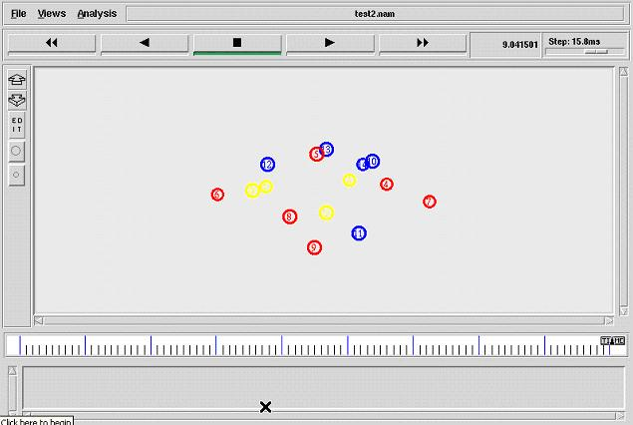

Tcl script to make TCP communication between nodes
Description:
Number of nodes (3) is fixed in the program. Nodes are configured with specific parameters of a mobile wireless node. After creating the nam file and trace file, we set up topography object. set node_ ($i) [$ns node] is used to create the nodes. Initial location of the nodes is fixed. Specific X, Y coordinates are assigned to every node. Nodes are given mobility with fixed speed and fixed destination location. Here we set the initial size for the every node by using initial_node_pos. AODV routing protocol is used here. $val(stop) specifies the end time of the simulation. TCP agent is attached to node_ (0). TCPSink agent is attached to node_(1). Both the agents are connected and FTP application is attached to TCP agent. Now communication set up for node_(0) and node_(1) is established. Similarly communication between node_(1) and node_(2) is established.
File name: “wireless1.tcl”
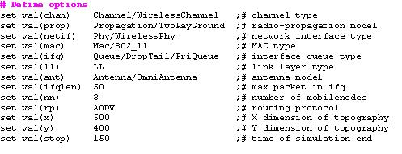
#-------Event scheduler object creation--------#
set ns [new Simulator]
#creating trace file and nam file
set tracefd [open wireless1.tr w]
set windowVsTime2 [open win.tr w]
set namtrace [open wireless1.nam w]
$ns trace-all $tracefd
$ns namtrace-all-wireless $namtrace $val(x) $val(y)
# set up topography object
set topo [new Topography]
$topo load_flatgrid $val(x) $val(y)
create-god $val(nn)
# configure the nodes
$ns node-config -adhocRouting $val(rp) \
-llType $val(ll) \
-macType $val(mac) \
-ifqType $val(ifq) \
-ifqLen $val(ifqlen) \
-antType $val(ant) \
-propType $val(prop) \
-phyType $val(netif) \
-channelType $val(chan) \
-topoInstance $topo \
-agentTrace ON \
-routerTrace ON \
-macTrace OFF \
-movementTrace ON
for {set i 0} {$i < $val(nn) } { incr i } {
set node_($i) [$ns node]
}
# Provide initial location of mobilenodes
$node_(0) set X_ 5.0
$node_(0) set Y_ 5.0
$node_(0) set Z_ 0.0
$node_(1) set X_ 490.0
$node_(1) set Y_ 285.0
$node_(1) set Z_ 0.0
$node_(2) set X_ 150.0
$node_(2) set Y_ 240.0
$node_(2) set Z_ 0.0
# Generation of movements
$ns at 10.0 "$node_(0) setdest 250.0 250.0 3.0"
$ns at 15.0 "$node_(1) setdest 45.0 285.0 5.0"
$ns at 19.0 "$node_(2) setdest 480.0 300.0 5.0"
# Set a TCP connection between node_(0) and node_(1)
set tcp [new Agent/TCP/Newreno]
$tcp set class_ 2
set sink [new Agent/TCPSink]
$ns attach-agent $node_(0) $tcp
$ns attach-agent $node_(1) $sink
$ns connect $tcp $sink
set ftp [new Application/FTP]
$ftp attach-agent $tcp
$ns at 10.0 "$ftp start"
set tcp [new Agent/TCP/Newreno]
$tcp set class_ 2
set sink [new Agent/TCPSink]
$ns attach-agent $node_(1) $tcp
$ns attach-agent $node_(2) $sink
$ns connect $tcp $sink
set ftp [new Application/FTP]
$ftp attach-agent $tcp
$ns at 10.0 "$ftp start"
# Printing the window size
proc plotWindow {tcpSource file} {
global ns
set time 0.01
set now [$ns now]
set cwnd [$tcpSource set cwnd_]
puts $file "$now $cwnd"
$ns at [expr $now+$time] "plotWindow $tcpSource $file" }
$ns at 10.0 "plotWindow $tcp $windowVsTime2"
# Define node initial position in nam
for {set i 0} {$i < $val(nn)} { incr i } {
# 30 defines the node size for nam
$ns initial_node_pos $node_($i) 30
}
# Telling nodes when the simulation ends
for {set i 0} {$i < $val(nn) } { incr i } {
$ns at $val(stop) "$node_($i) reset";
}
# ending nam and the simulation
$ns at $val(stop) "$ns nam-end-wireless $val(stop)"
$ns at $val(stop) "stop"
$ns at 150.01 "puts \"end simulation\" ; $ns halt"
proc stop {} {
global ns tracefd namtrace
$ns flush-trace
close $tracefd
close $namtrace
exec nam simwrls.nam &
}
$ns run
# How to run the program:
$ns wireless1.tcl
#snapshot of the program:
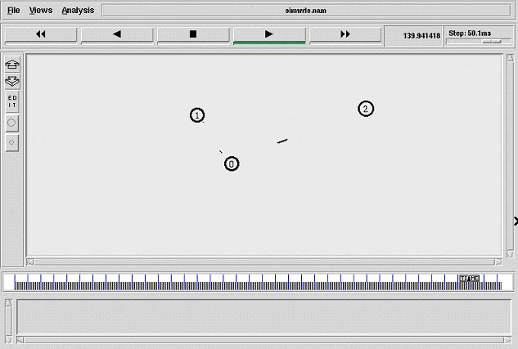

Tcl script to make TCP communication between nodes using DSR routing protocol
Description:
Number of nodes (3) is fixed in the program. Nodes are configured with specific parameters of a mobile wireless node. After creating the nam file and trace file, we set up topography object. set node_ ($i) [$ns node] is used to create the nodes. Initial location of the nodes is fixed. Specific X, Y coordinates are assigned to every node. Nodes are given mobility with fixed speed and fixed destination location. Here we set the initial size for the every node by using initial_node_pos. DSR routing protocol is used here. $val(stop) specifies the end time of the simulation. TCP agent is attached to node_ (0). TCPSink agent is attached to node_(1). Both the agents are connected and FTP application is attached to TCP agent. Now communication set up for node_(0) and node_(1) is established
File name: “Dsr.tcl”
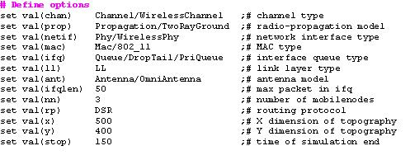
#-------Event scheduler object creation--------#
set ns [new Simulator]
#Creating trace file and nam file
set tracefd [open dsr.tr w]
set windowVsTime2 [open win.tr w]
set namtrace [open dsr.nam w]
$ns trace-all $tracefd
$ns namtrace-all-wireless $namtrace $val(x) $val(y)
# set up topography object
set topo [new Topography]
$topo load_flatgrid $val(x) $val(y)
create-god $val(nn)
# configure the nodes
$ns node-config -adhocRouting $val(rp) \
-llType $val(ll) \
-macType $val(mac) \
-ifqType $val(ifq) \
-ifqLen $val(ifqlen) \
-antType $val(ant) \
-propType $val(prop) \
-phyType $val(netif) \
-channelType $val(chan) \
-topoInstance $topo \
-agentTrace ON \
-routerTrace ON \
-macTrace OFF \
-movementTrace ON
for {set i 0} {$i < $val(nn) } { incr i } {
set node_($i) [$ns node]
}
# Provide initial location of mobilenodes
$node_(0) set X_ 5.0
$node_(0) set Y_ 5.0
$node_(0) set Z_ 0.0
$node_(1) set X_ 490.0
$node_(1) set Y_ 285.0
$node_(1) set Z_ 0.0
$node_(2) set X_ 150.0
$node_(2) set Y_ 240.0
$node_(2) set Z_ 0.0
# Generation of movements
$ns at 10.0 "$node_(0) setdest 250.0 250.0 3.0"
$ns at 15.0 "$node_(1) setdest 45.0 285.0 5.0"
$ns at 110.0 "$node_(0) setdest 480.0 300.0 5.0"
# Set a TCP connection between node_(0) and node_(1)
set tcp [new Agent/TCP/Newreno]
$tcp set class_ 2
set sink [new Agent/TCPSink]
$ns attach-agent $node_(0) $tcp
$ns attach-agent $node_(1) $sink
$ns connect $tcp $sink
set ftp [new Application/FTP]
$ftp attach-agent $tcp
$ns at 10.0 "$ftp start"
# Printing the window size
proc plotWindow {tcpSource file} {
global ns
set time 0.01
set now [$ns now]
set cwnd [$tcpSource set cwnd_]
puts $file "$now $cwnd"
$ns at [expr $now+$time] "plotWindow $tcpSource $file" }
$ns at 10.1 "plotWindow $tcp $windowVsTime2"
# Define node initial position in nam
for {set i 0} {$i < $val(nn)} { incr i } {
# 30 defines the node size for nam
$ns initial_node_pos $node_($i) 30
}
# Telling nodes when the simulation ends
for {set i 0} {$i < $val(nn) } { incr i } {
$ns at $val(stop) "$node_($i) reset";
}
# ending nam and the simulation
$ns at $val(stop) "$ns nam-end-wireless $val(stop)"
$ns at $val(stop) "stop"
$ns at 150.01 "puts \"end simulation\" ; $ns halt"
proc stop {} {
global ns tracefd namtrace
$ns flush-trace
close $tracefd
close $namtrace
exec nam dsr.nam &
exit 0
}
$ns run
# How to run the program:
$ns dsr.tcl
#snapshot of the program:
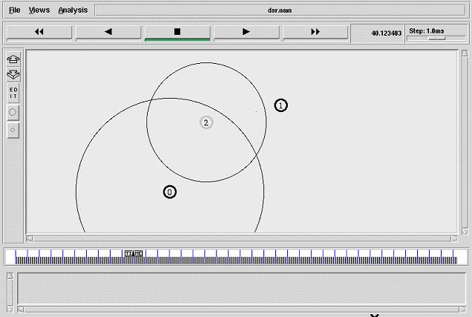
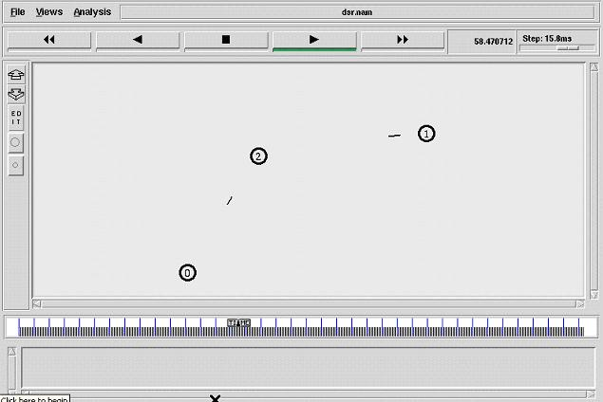

Tcl script to make communication between nodes using AODV routing protocol and CBR traffic
Description:
Number of nodes (22) is fixed in the program. Nodes are configured with specific parameters of a mobile wireless node. After creating the nam file and trace file, we set up topography object. set node_ ($i) [$ns node] is used to create the nodes. Initial location of the nodes is fixed. Specific X, Y coordinates are assigned to every node. Nodes are given mobility with fixed speed and fixed destination location. Here we set the initial size for the every node by using initial_node_pos. AODV routing protocol is used here. $val(stop) specifies the end time of the simulation. UDP agent is attached to sender node. LossMonitor agent is attached to receiver node. Both the agents are connected and CBR traffic is attached to UDP agent. Now communication set up for nodes are established.
File name: “Aodv.tcl”
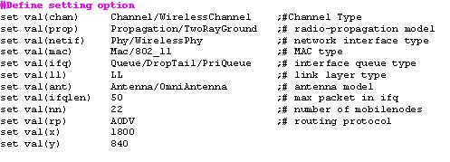
### Setting The Simulator Objects
set ns_ [new Simulator]
#create the nam and trace file:
set tracefd [open aodv.tr w]
$ns_ trace-all $tracefd
set namtrace [open aodv.nam w]
$ns_ namtrace-all-wireless $namtrace $val(x) $val(y)
set topo [new Topography]
$topo load_flatgrid $val(x) $val(y)
create-god $val(nn)
set chan_1_ [new $val(chan)]
#### Setting The Distance Variables
# For model 'TwoRayGround'
set dist(5m) 7.69113e-06
set dist(9m) 2.37381e-06
set dist(10m) 1.92278e-06
set dist(11m) 1.58908e-06
set dist(12m) 1.33527e-06
set dist(13m) 1.13774e-06
set dist(14m) 9.81011e-07
set dist(15m) 8.54570e-07
set dist(16m) 7.51087e-07
set dist(20m) 4.80696e-07
set dist(25m) 3.07645e-07
set dist(30m) 2.13643e-07
set dist(35m) 1.56962e-07
set dist(40m) 1.56962e-10
set dist(45m) 1.56962e-11
set dist(50m) 1.20174e-13
Phy/WirelessPhy set CSThresh_ $dist(50m)
Phy/WirelessPhy set RXThresh_ $dist(50m)
# Defining Node Configuration
$ns_ node-config -adhocRouting $val(rp) \
-llType $val(ll) \
-macType $val(mac) \
-ifqType $val(ifq) \
-ifqLen $val(ifqlen) \
-antType $val(ant) \
-propType $val(prop) \
-phyType $val(netif) \
-topoInstance $topo \
-agentTrace ON \
-routerTrace ON \
-macTrace ON \
-movementTrace ON \
-channel $chan_1_
### Creating The WIRELESS NODES
set Server1 [$ns_ node]
set Server2 [$ns_ node]
set n2 [$ns_ node]
set n3 [$ns_ node]
set n4 [$ns_ node]
set n5 [$ns_ node]
set n6 [$ns_ node]
set n7 [$ns_ node]
set n8 [$ns_ node]
set n9 [$ns_ node]
set n10 [$ns_ node]
set n11 [$ns_ node]
set n12 [$ns_ node]
set n13 [$ns_ node]
set n14 [$ns_ node]
set n15 [$ns_ node]
set n16 [$ns_ node]
set n17 [$ns_ node]
set n18 [$ns_ node]
set n19 [$ns_ node]
set n20 [$ns_ node]
set n21 [$ns_ node]
set n22 [$ns_ node]
set opt(seed) 0.1
set a [ns-random $opt(seed)]
set i 0
while {$i < 5} {
incr i
}
### Setting The Initial Positions of Nodes
$Server1 set X_ 513.0
$Server1 set Y_ 517.0
$Server1 set Z_ 0.0
$Server2 set X_ 1445.0
$Server2 set Y_ 474.0
$Server2 set Z_ 0.0
$n2 set X_ 36.0
$n2 set Y_ 529.0
$n2 set Z_ 0.0
$n3 set X_ 143.0
$n3 set Y_ 666.0
$n3 set Z_ 0.0
$n4 set X_ 201.0
$n4 set Y_ 552.0
$n4 set Z_ 0.0
$n5 set X_ 147.0
$n5 set Y_ 403.0
$n5 set Z_ 0.0
$n6 set X_ 230.0
$n6 set Y_ 291.0
$n6 set Z_ 0.0
$n7 set X_ 295.0
$n7 set Y_ 419.0
$n7 set Z_ 0.0
$n8 set X_ 363.0
$n8 set Y_ 335.0
$n8 set Z_ 0.0
$n9 set X_ 334.0
$n9 set Y_ 647.0
$n9 set Z_ 0.0
$n10 set X_ 304.0
$n10 set Y_ 777.0
$n10 set Z_ 0.0
$n11 set X_ 412.0
$n11 set Y_ 194.0
$n11 set Z_ 0.0
$n12 set X_ 519.0
$n12 set Y_ 361.0
$n12 set Z_ 0.0
$n13 set X_ 569.0
$n13 set Y_ 167.0
$n13 set Z_ 0.0
$n14 set X_ 349.0
$n14 set Y_ 546.0
$n14 set Z_ 0.0
$n15 set X_ 466.0
$n15 set Y_ 668.0
$n15 set Z_ 0.0
$n16 set X_ 489.0
$n16 set Y_ 794.0
$n16 set Z_ 0.0
$n17 set X_ 606.0
$n17 set Y_ 711.0
$n17 set Z_ 0.0
$n18 set X_ 630.0
$n18 set Y_ 626.0
$n18 set Z_ 0.0
$n19 set X_ 666.0
$n19 set Y_ 347.0
$n19 set Z_ 0.0
$n20 set X_ 741.0
$n20 set Y_ 152.0
$n20 set Z_ 0.0
$n21 set X_ 882.0
$n21 set Y_ 264.0
$n21 set Z_ 0.0
$n22 set X_ 761.0
$n22 set Y_ 441.0
$n22 set Z_ 0.0
## Giving Mobility to Nodes
$ns_ at 0.75 "$n2 setdest 379.0 349.0 20.0"
$ns_ at 0.75 "$n3 setdest 556.0 302.0 20.0"
$ns_ at 0.20 "$n4 setdest 309.0 211.0 20.0"
$ns_ at 1.25 "$n5 setdest 179.0 333.0 20.0"
$ns_ at 0.75 "$n6 setdest 139.0 63.0 20.0"
$ns_ at 0.75 "$n7 setdest 320.0 27.0 20.0"
$ns_ at 1.50 "$n8 setdest 505.0 124.0 20.0"
$ns_ at 1.25 "$n9 setdest 274.0 487.0 20.0"
$ns_ at 1.25 "$n10 setdest 494.0 475.0 20.0"
$ns_ at 1.25 "$n11 setdest 899.0 757.0 25.0"
$ns_ at 0.50 "$n12 setdest 598.0 728.0 25.0"
$ns_ at 0.25 "$n13 setdest 551.0 624.0 25.0"
$ns_ at 1.25 "$n14 setdest 397.0 647.0 25.0"
$ns_ at 1.25 "$n15 setdest 748.0 688.0 25.0"
$ns_ at 1.25 "$n16 setdest 842.0 623.0 25.0"
$ns_ at 1.25 "$n17 setdest 678.0 548.0 25.0"
$ns_ at 0.75 "$n18 setdest 741.0 809.0 20.0"
$ns_ at 0.75 "$n19 setdest 437.0 799.0 20.0"
$ns_ at 0.20 "$n20 setdest 159.0 722.0 20.0"
$ns_ at 1.25 "$n21 setdest 700.0 350.0 20.0"
$ns_ at 0.75 "$n22 setdest 839.0 444.0 20.0"
## Setting The Node Size
$ns_ initial_node_pos $Server1 75
$ns_ initial_node_pos $Server2 75
$ns_ initial_node_pos $n2 40
$ns_ initial_node_pos $n3 40
$ns_ initial_node_pos $n4 40
$ns_ initial_node_pos $n5 40
$ns_ initial_node_pos $n6 40
$ns_ initial_node_pos $n7 40
$ns_ initial_node_pos $n8 40
$ns_ initial_node_pos $n9 40
$ns_ initial_node_pos $n10 40
$ns_ initial_node_pos $n11 40
$ns_ initial_node_pos $n12 40
$ns_ initial_node_pos $n13 40
$ns_ initial_node_pos $n14 40
$ns_ initial_node_pos $n15 40
$ns_ initial_node_pos $n16 40
$ns_ initial_node_pos $n17 40
$ns_ initial_node_pos $n18 40
$ns_ initial_node_pos $n19 40
$ns_ initial_node_pos $n20 40
$ns_ initial_node_pos $n21 40
$ns_ initial_node_pos $n22 40
#### Setting The Labels For Nodes
$ns_ at 0.0 "$Server1 label Server1"
$ns_ at 0.0 "$Server2 label Server2"
#Setting Color For Server
$Server1 color maroon
$ns_ at 0.0 "$Server1 color maroon"
$Server2 color maroon
$ns_ at 0.0 "$Server2 color maroon"
## SETTING ANIMATION RATE
$ns_ at 0.0 "$ns_ set-animation-rate 15.0ms"
# COLORING THE NODES
$n9 color blue
$ns_ at 4.71 "$n9 color blue"
$n5 color blue
$ns_ at 7.0 "$n5 color blue"
$n2 color blue
$ns_ at 7.29 "$n2 color blue"
$n16 color blue
$ns_ at 7.59 "$n16 color blue"
$n9 color maroon
$ns_ at 7.44 "$n9 color maroon"
$ns_ at 7.43 "$n9 label TTLover"
$ns_ at 7.55 "$n9 label \"\""
$n12 color blue
$ns_ at 7.85 "$n12 color blue"
#### Establishing Communication
set udp0 [$ns_ create-connection UDP $Server1 LossMonitor $n18 0]
$udp0 set fid_ 1
set cbr0 [$udp0 attach-app Traffic/CBR]
$cbr0 set packetSize_ 1000
$cbr0 set interval_ .07
$ns_ at 0.0 "$cbr0 start"
$ns_ at 4.0 "$cbr0 stop"
set udp1 [$ns_ create-connection UDP $Server1 LossMonitor $n22 0]
$udp1 set fid_ 1
set cbr1 [$udp1 attach-app Traffic/CBR]
$cbr1 set packetSize_ 1000
$cbr1 set interval_ .07
$ns_ at 0.1 "$cbr1 start"
$ns_ at 4.1 "$cbr1 stop"
set udp2 [$ns_ create-connection UDP $n21 LossMonitor $n20 0]
$udp2 set fid_ 1
set cbr2 [$udp2 attach-app Traffic/CBR]
$cbr2 set packetSize_ 1000
$cbr2 set interval_ .07
$ns_ at 2.4 "$cbr2 start"
$ns_ at 4.1 "$cbr2 stop"
set udp3 [$ns_ create-connection UDP $Server1 LossMonitor $n15 0]
$udp3 set fid_ 1
set cbr3 [$udp3 attach-app Traffic/CBR]
$cbr3 set packetSize_ 1000
$cbr3 set interval_ 5
$ns_ at 4.0 "$cbr3 start"
$ns_ at 4.1 "$cbr3 stop"
set udp4 [$ns_ create-connection UDP $Server1 LossMonitor $n14 0]
$udp4 set fid_ 1
set cbr4 [$udp4 attach-app Traffic/CBR]
$cbr4 set packetSize_ 1000
$cbr4 set interval_ 5
$ns_ at 4.0 "$cbr4 start"
$ns_ at 4.1 "$cbr4 stop"
set udp5 [$ns_ create-connection UDP $n15 LossMonitor $n16 0]
$udp5 set fid_ 1
set cbr5 [$udp5 attach-app Traffic/CBR]
$cbr5 set packetSize_ 1000
$cbr5 set interval_ 5
$ns_ at 4.0 "$cbr5 start"
$ns_ at 4.1 "$cbr5 stop"
set udp6 [$ns_ create-connection UDP $n15 LossMonitor $n17 0]
$udp6 set fid_ 1
set cbr6 [$udp6 attach-app Traffic/CBR]
$cbr6 set packetSize_ 1000
$cbr6 set interval_ 5
$ns_ at 4.0 "$cbr6 start"
$ns_ at 4.1 "$cbr6 stop"
set udp7 [$ns_ create-connection UDP $n14 LossMonitor $n4 0]
$udp7 set fid_ 1
set cbr7 [$udp7 attach-app Traffic/CBR]
$cbr7 set packetSize_ 1000
$cbr7 set interval_ 5
$ns_ at 4.0 "$cbr7 start"
$ns_ at 4.1 "$cbr7 stop"
set udp8 [$ns_ create-connection UDP $n14 LossMonitor $n9 0]
$udp8 set fid_ 1
set cbr8 [$udp8 attach-app Traffic/CBR]
$cbr8 set packetSize_ 1000
$cbr8 set interval_ 5
$ns_ at 4.0 "$cbr8 start"
$ns_ at 4.1 "$cbr8 stop"
set udp9 [$ns_ create-connection UDP $n4 LossMonitor $n3 0]
$udp9 set fid_ 1
set cbr9 [$udp9 attach-app Traffic/CBR]
$cbr9 set packetSize_ 1000
$cbr9 set interval_ 5
$ns_ at 4.0 "$cbr9 start"
$ns_ at 4.1 "$cbr9 stop"
set udp10 [$ns_ create-connection UDP $n4 LossMonitor $n2 0]
$udp10 set fid_ 1
set cbr10 [$udp10 attach-app Traffic/CBR]
$cbr10 set packetSize_ 1000
$cbr10 set interval_ 5
$ns_ at 4.0 "$cbr10 start"
$ns_ at 4.1 "$cbr10 stop"
set udp11 [$ns_ create-connection UDP $n9 LossMonitor $n16 0]
$udp11 set fid_ 1
set cbr11 [$udp11 attach-app Traffic/CBR]
$cbr11 set packetSize_ 1000
$cbr11 set interval_ 5
$ns_ at 4.0 "$cbr11 start"
$ns_ at 4.1 "$cbr11 stop"
set udp12 [$ns_ create-connection UDP $n9 LossMonitor $n10 0]
$udp12 set fid_ 1
set cbr12 [$udp12 attach-app Traffic/CBR]
$cbr12 set packetSize_ 1000
$cbr12 set interval_ 5
$ns_ at 4.0 "$cbr12 start"
$ns_ at 4.1 "$cbr12 stop"
#ANNOTATIONS DETAILS
$ns_ at 0.0 "$ns_ trace-annotate \"MOBILE NODE MOVEMENTS\""
$ns_ at 4.1 "$ns_ trace-annotate \"NODE27 CACHE THE DATA FRO SERVER\""
#$ns_ at 4.59 "$ns_ trace-annotate \"PACKET LOSS AT NODE27\""
$ns_ at 4.71 "$ns_ trace-annotate \"NODE10 CACHE THE DATA\""
### PROCEDURE TO STOP
proc stop {} {
global ns_ tracefd
$ns_ flush-trace
close $tracefd
exec nam datacache.nam &
exit 0
}
puts "Starting Simulation........"
$ns_ at 25.0 "stop"
$ns_ run
# How to run the program:
$ns aodv1.tcl
#snapshot of the program:
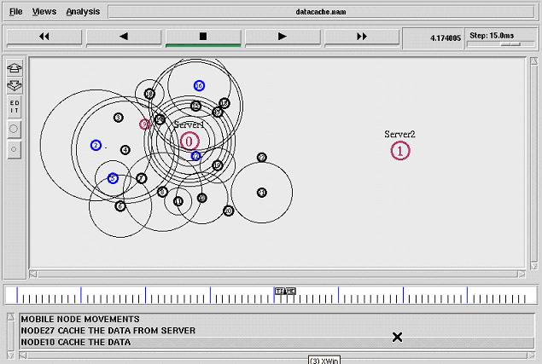

cl script to make TCP communication between nodes using DSDV routing protocol
Description:
Number of nodes (3) is fixed in the program. Nodes are configured with specific parameters of a mobile wireless node. After creating the nam file and trace file, we set up topography object. set node_ ($i) [$ns node] is used to create the nodes. Initial location of the nodes is fixed. Specific X, Y coordinates are assigned to every node. Nodes are given mobility with fixed speed and fixed destination location. Here we set the initial size for the every node by using initial_node_pos. DSDV routing protocol is used here. $val(stop) specifies the end time of the simulation. TCP agent is attached to node_ (0). TCPSink agent is attached to node_(1). Both the agents are connected and FTP application is attached to TCP agent. Now communication set up for node_(0) and node_(1) is established.
File name: “dsdv.tcl”
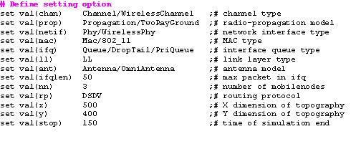
#Creating trace file and nam file
set tracefd [open dsdv.tr w]
set windowVsTime2 [open win.tr w]
set namtrace [open dsdv.nam w]
$ns trace-all $tracefd
$ns namtrace-all-wireless $namtrace $val(x) $val(y)
# set up topography object
set topo [new Topography]
$topo load_flatgrid $val(x) $val(y)
create-god $val(nn)
# configure the nodes
$ns node-config -adhocRouting $val(rp) \
-llType $val(ll) \
-macType $val(mac) \
-ifqType $val(ifq) \
-ifqLen $val(ifqlen) \
-antType $val(ant) \
-propType $val(prop) \
-phyType $val(netif) \
-channelType $val(chan) \
-topoInstance $topo \
-agentTrace ON \
-routerTrace ON \
-macTrace OFF \
-movementTrace ON
for {set i 0} {$i < $val(nn) } { incr i } {
set node_($i) [$ns node]
}
# Provide initial location of mobilenodes
$node_(0) set X_ 5.0
$node_(0) set Y_ 5.0
$node_(0) set Z_ 0.0
$node_(1) set X_ 490.0
$node_(1) set Y_ 285.0
$node_(1) set Z_ 0.0
$node_(2) set X_ 150.0
$node_(2) set Y_ 240.0
$node_(2) set Z_ 0.0
# Generation of movements
$ns at 10.0 "$node_(0) setdest 250.0 250.0 3.0"
$ns at 15.0 "$node_(1) setdest 45.0 285.0 5.0"
$ns at 110.0 "$node_(0) setdest 480.0 300.0 5.0"
# Set a TCP connection between node_(0) and node_(1)
set tcp [new Agent/TCP/Newreno]
$tcp set class_ 2
set sink [new Agent/TCPSink]
$ns attach-agent $node_(0) $tcp
$ns attach-agent $node_(1) $sink
$ns connect $tcp $sink
set ftp [new Application/FTP]
$ftp attach-agent $tcp
$ns at 10.0 "$ftp start"
# Printing the window size
proc plotWindow {tcpSource file} {
global ns
set time 0.01
set now [$ns now]
set cwnd [$tcpSource set cwnd_]
puts $file "$now $cwnd"
$ns at [expr $now+$time] "plotWindow $tcpSource $file" }
$ns at 10.1 "plotWindow $tcp $windowVsTime2"
# Define node initial position in nam
for {set i 0} {$i < $val(nn)} { incr i } {
# 30 defines the node size for nam
$ns initial_node_pos $node_($i) 30
}
# Telling nodes when the simulation ends
for {set i 0} {$i < $val(nn) } { incr i } {
$ns at $val(stop) "$node_($i) reset";
}
# ending nam and the simulation
$ns at $val(stop) "$ns nam-end-wireless $val(stop)"
$ns at $val(stop) "stop"
$ns at 150.01 "puts \"end simulation\" ; $ns halt"
proc stop {} {
global ns tracefd namtrace
$ns flush-trace
close $tracefd
close $namtrace
exec nam dsdv.nam &
exit 0
}
$ns run
# How to run the program:
$ns dsdv.tcls
#snapshot of the program:
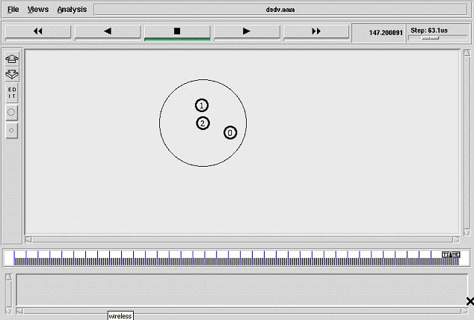

Setting Energy Model for Mobile Nodes.
Description:
Number of nodes (4) is fixed in the program. Nodes are configured with specific parameters of a mobile wireless node. Here we use the energy model for each node with -initialEnergy 20 \ -txPower 0.9 \-rxPower 0.8 \-idlePower 0.0 \ -sensePower 0.0175. After creating the nam file and trace file, we set up topography object. set node_ ($i) [$ns node] is used to create the nodes. Initial location of the nodes is fixed. Specific X, Y coordinates are assigned to every node. Nodes are given mobility with fixed speed and random destination location. Here we set the initial size for the every node by using initial_node_pos. DSR routing protocol is used here. $val(stop) specifies the end time of the simulation
File name: “wireless1.tcl”
## Setting The wireless Channels..
set val(chan) Channel/WirelessChannel ;# channel type
set val(prop) Propagation/TwoRayGround ;# radio-propagation model
set val(netif) Phy/WirelessPhy ;# network interface type
set val(mac) Mac/802_11 ;# MAC type
set val(ifq) Queue/DropTail/PriQueue ;# interface queue type
set val(ll) LL ;# link layer type
set val(ant) Antenna/OmniAntenna ;# antenna model
set val(ifqlen) 5 ;# max packet in ifq
set val(nn) 6 ;# number of mobilenodes
set val(rp) DSR ;# routing protocol
set val(x) 750 ;# X dimension of topography
set val(y) 550 ;# Y dimension of topography
set val(stop) 18.0 ;# time of simulation end
## Create a simulator object(nothing but, a scheduler's object)..
set ns [new Simulator]
## Create a trace file and nam file..
set tracefd [open wireless1.tr w]
set namtrace [open wireless1.nam w]
## Trace the nam and trace details from the main simulation..
$ns trace-all $tracefd
$ns namtrace-all-wireless $namtrace $val(x) $val(y)
## set up topography object..
set topo [new Topography]
$topo load_flatgrid $val(x) $val(y)
set god_ [create-god $val(nn)]
## Color Descriptions..
$ns color 1 dodgerblue
$ns color 2 blue
$ns color 3 cyan
$ns color 4 green
$ns color 5 yellow
$ns color 6 black
$ns color 7 magenta
$ns color 8 gold
$ns color 9 red
# Setting The Distance Variables..
# For model 'TwoRayGround'
set dist(5m) 7.69113e-06
set dist(9m) 2.37381e-06
set dist(10m) 1.92278e-06
set dist(11m) 1.58908e-06
set dist(12m) 1.33527e-06
set dist(13m) 1.13774e-06
set dist(14m) 9.81011e-07
set dist(15m) 8.54570e-07
set dist(16m) 7.51087e-07
set dist(20m) 4.80696e-07
set dist(25m) 3.07645e-07
set dist(30m) 2.13643e-07
set dist(35m) 1.56962e-07
set dist(40m) 1.56962e-10
set dist(45m) 1.56962e-11
set dist(50m) 1.20174e-13
#Phy/WirelessPhy set CSThresh_ $dist(50m)
#Phy/WirelessPhy set RXThresh_ $dist(50m)
## Setting node config event with set of inputs..
puts "Node Configuration Started here...\n \
-channel $val(chan) \n \
-adhocRouting $val(rp) \n \
-llType $val(ll) \n \
-macType $val(mac) \n \
-ifqType $val(ifq) \n \
-ifqLen $val(ifqlen) \n \
-antType $val(ant) \n \
-propType $val(prop) \n \
-phyType $val(netif) \n"
$ns node-config -adhocRouting $val(rp) \
-llType $val(ll) \
-macType $val(mac) \
-ifqType $val(ifq) \
-ifqLen $val(ifqlen) \
-antType $val(ant) \
-propType $val(prop) \
-phyType $val(netif) \
-channelType $val(chan) \
-topoInstance $topo \
-agentTrace ON \
-routerTrace ON \
-macTrace OFF \
-movementTrace ON
# Energy model
$ns node-config -energyModel EnergyModel \
-initialEnergy 20 \
-txPower 0.9 \
-rxPower 0.8 \
-idlePower 0.0 \
-sensePower 0.0175
## Creating node objects..
for {set i 0} {$i < $val(nn) } { incr i } {
set node_($i) [$ns node]
}
for {set i 0} {$i < $val(nn)} {incr i} {
$node_($i) color darkgreen
$ns at 0.0 "$node_($i) color darkgreen"
}
## Provide initial location of mobilenodes..
if {$val(nn) >0} {
for {set i 1} {$i < $val(nn) } { incr i } {
set xx [expr rand()*600]
set yy [expr rand()*500];
$node_($i) set X_ $xx
$node_($i) set Y_ $yy
}
}
## set god distance..
$god_ set-dist 0 1 2
$god_ set-dist 0 2 2
$god_ set-dist 0 3 2
$god_ set-dist 0 4 1
$god_ set-dist 0 5 2
$god_ set-dist 1 2 3
$god_ set-dist 1 3 3
## Define node initial position in nam..
for {set i 0} {$i < $val(nn)} { incr i } {
# 30 defines the node size for nam..
$ns initial_node_pos $node_($i) 30
}
## Telling nodes when the simulation ends..
for {set i 0} {$i < $val(nn) } { incr i } {
$ns at $val(stop) "$node_($i) reset";
}
## Ending nam and the simulation..
$ns at $val(stop) "$ns nam-end-wireless $val(stop)"
$ns at $val(stop) "stop"
$ns at 16.01 "puts \"end simulation\" " ;# $ns halt

## Stop procedure..
proc stop {} {
global ns tracefd namtrace
$ns flush-trace
close $tracefd
close $namtrace
exec nam wireless1.nam &
exit 0
}
$ns run
#how to run this program...
$ns wireless1.tcl
# snapshot of the program:
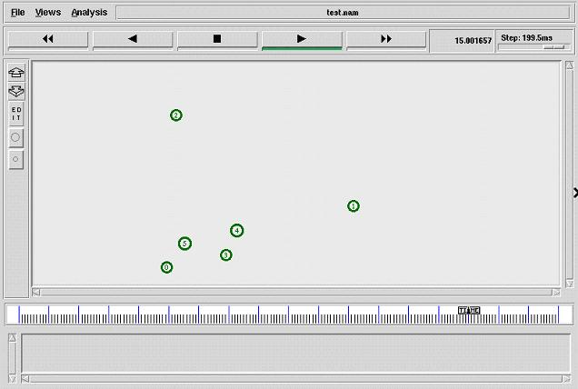

Tcl script to set nodes destination randomly at particular time interval.
Destination:
Number of nodes is not fixed in the program. We can give the number of nodes to be created during runtime. Number of nodes should be given as command line arguments when we run the coding. Dynamically created nodes are configured with specific parameters of a mobile wireless node. After creating the nam file and trace file, we set up topography object. set node_ ($i) [$ns node] is used to create the nodes. Initial location of the nodes is not fixed. X, Y coordinates are randomly selected and assigned to every node. Nodes are given mobility with fixed speed and random destination. Destination location will be changed time to time. Here we set the initial size for the every node by using initial_node_pos. AODV routing protocol is used here. $val(stop) specifies the end time of the simulation.
File name: “wireless1.tcl”
# Define options
set val(chan) Channel/WirelessChannel ;# channel type
set val(prop) Propagation/TwoRayGround ;# radio-propagation model
set val(netif) Phy/WirelessPhy ;# network interface type
set val(mac) Mac/802_11 ;# MAC type
set val(ifq) Queue/DropTail/PriQueue ;# interface queue type
set val(ll) LL ;# link layer type
set val(ant) Antenna/OmniAntenna ;# antenna model
set val(ifqlen) 50 ;# max packet in ifq
set val(nn) 5 ;# number of mobilenodes
set val(rp) AODV ;# routing protocol
set val(x) 500 ;# X dimension of topography
set val(y) 400 ;# Y dimension of topography
set val(stop) 10 ;# time of simulation end

set ns [new Simulator]
#Creating nam and trace file:
set tracefd [open wireless1.tr w]
set namtrace [open wireless1.nam w]
$ns trace-all $tracefd
$ns namtrace-all-wireless $namtrace $val(x) $val(y)
# set up topography object
set topo [new Topography]
$topo load_flatgrid $val(x) $val(y)
set god_ [create-god $val(nn)]
# configure the nodes
$ns node-config -adhocRouting $val(rp) \
-llType $val(ll) \
-macType $val(mac) \
-ifqType $val(ifq) \
-ifqLen $val(ifqlen) \
-antType $val(ant) \
-propType $val(prop) \
-phyType $val(netif) \
-channelType $val(chan) \
-topoInstance $topo \
-agentTrace ON \
-routerTrace ON \
-macTrace OFF \
-movementTrace ON
## Creating node objects..
for {set i 0} {$i < $val(nn) } { incr i } {
set node_($i) [$ns node]
}
for {set i 0} {$i < $val(nn) } {incr i } {
$node_($i) color black
$ns at 0.0 "$node_($i) color black"
}

## Provide initial location of mobilenodes..
for {set i 0} {$i < $val(nn) } { incr i } {
set xx [expr rand()*500]
set yy [expr rand()*400]
$node_($i) set X_ $xx
$node_($i) set Y_ $yy
}
# Define node initial position in nam
for {set i 0} {$i < $val(nn)} { incr i } {
# 30 defines the node size for nam
$ns initial_node_pos $node_($i) 30
}
# Telling nodes when the simulation ends
for {set i 0} {$i < $val(nn) } { incr i } {
$ns at $val(stop) "$node_($i) reset";
}
#Destination procedure..
$ns at 0.0 "destination"
proc destination {} {
global ns val node_
set time 1.0
set now [$ns now]
for {set i 0} {$i<$val(nn)} {incr i} {
set xx [expr rand()*500]
set yy [expr rand()*400]
$ns at $now "$node_($i) setdest $xx $yy 10.0"
}
$ns at [expr $now+$time] "destination"
}
$ns at $val(stop) "stop"
#Stop procedure
proc stop {} {
global ns tracefd namtrace
$ns flush-trace
close $tracefd
close $namtrace
exec nam wireless1.nam &
}
$ns run
# How to run the program:
$ns wireless1.tcl
#snapshot of the program:

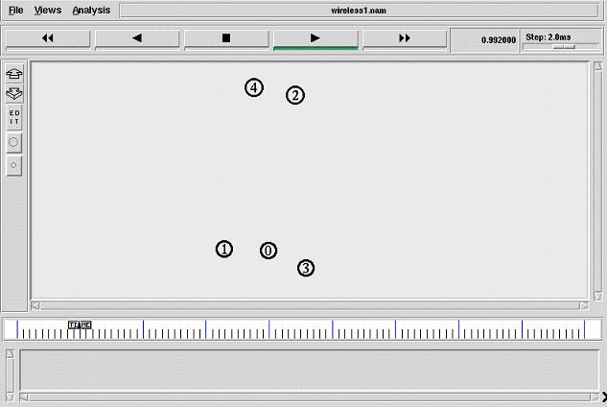

Tcl script to set nodes destination and color randomly .
Destination:
Number of nodes is not fixed in the program. We can give the number of nodes to be created during runtime. Number of nodes should be given as command line arguments when we run the coding. Dynamically created nodes are configured with specific parameters of a mobile wireless node. After creating the nam file and trace file, we set up topography object. set node_ ($i) [$ns node] is used to create the nodes. Initial location of the nodes is not fixed. X, Y coordinates are randomly selected and assigned to every node. Nodes are given mobility with fixed speed and random destination. Destination location will be changed time to time. Here we set the initial size for the every node by using initial_node_pos. AODV routing protocol is used here. $val(stop) specifies the end time of the simulation. Each group of nodes are given different color.
File name: “wireless2.tcl”
# Define setting options
set val(chan) Channel/WirelessChannel ;# channel type
set val(prop) Propagation/TwoRayGround ;# radio-propagation model
set val(netif) Phy/WirelessPhy ;# network interface type
set val(mac) Mac/802_11 ;# MAC type
set val(ifq) Queue/DropTail/PriQueue ;# interface queue type
set val(ll) LL ;# link layer type
set val(ant) Antenna/OmniAntenna ;# antenna model
set val(ifqlen) 50 ;# max packet in ifq
set val(nn) 8 ;# number of mobilenodes
set val(rp) AODV ;# routing protocol
set val(x) 500 ;# X dimension of topography
set val(y) 400 ;# Y dimension of topography
set val(stop) 10 ;# time of simulation end
set ns [new Simulator]
#Creating nam and trace file:
set tracefd [open wireless2.tr w]
set namtrace [open wireless2.nam w]
$ns trace-all $tracefd
$ns namtrace-all-wireless $namtrace $val(x) $val(y)
# set up topography object
set topo [new Topography]
$topo load_flatgrid $val(x) $val(y)
set god_ [create-god $val(nn)]
# configure the nodes
$ns node-config -adhocRouting $val(rp) \
-llType $val(ll) \
-macType $val(mac) \
-ifqType $val(ifq) \
-ifqLen $val(ifqlen) \
-antType $val(ant) \
-propType $val(prop) \
-phyType $val(netif) \
-channelType $val(chan) \
-topoInstance $topo \
-agentTrace ON \
-routerTrace ON \
-macTrace OFF \
-movementTrace ON
## Creating node objects..
for {set i 0} {$i < 3 } { incr i } {
set node_($i) [$ns node]
}
for {set i 0} {$i < 3 } {incr i } {
$node_($i) color blue
$ns at 0.0 "$node_($i) color blue"
}
for {set i 3} {$i < 6 } { incr i } {
set node_($i) [$ns node]
}
for {set i 3} {$i < 5 } {incr i } {
$node_($i) color cyan
$ns at 0.0 "$node_($i) color cyan"
}
for {set i 5} {$i < 8 } { incr i } {
set node_($i) [$ns node]
}
for {set i 5} {$i < 8 } {incr i } {
$node_($i) color red
$ns at 0.0 "$node_($i) color red"
}
## Provide initial location of mobilenodes..
for {set i 0} {$i < $val(nn) } { incr i } {
set xx [expr rand()*500]
set yy [expr rand()*400]
$node_($i) set X_ $xx
$node_($i) set Y_ $yy
}
# Define node initial position in nam
for {set i 0} {$i < $val(nn)} { incr i } {
# 30 defines the node size for nam
$ns initial_node_pos $node_($i) 30
}
# Telling nodes when the simulation ends
for {set i 0} {$i < $val(nn) } { incr i } {
$ns at $val(stop) "$node_($i) reset";
}
# dynamic destination setting procedure..
$ns at 0.0 "destination"
proc destination {} {
global ns val node_
set time 1.0
set now [$ns now]
for {set i 0} {$i<$val(nn)} {incr i} {
set xx [expr rand()*500]
set yy [expr rand()*400]
$ns at $now "$node_($i) setdest $xx $yy 10.0"
}
$ns at [expr $now+$time] "destination"
}
#stop procedure..
$ns at $val(stop) "stop"
proc stop {} {
global ns tracefd namtrace
$ns flush-trace
close $tracefd
close $namtrace
exec nam wireless2.nam &
}
$ns run
# How to run the program:
$ns wireless2.tcl
#snapshot of the program:
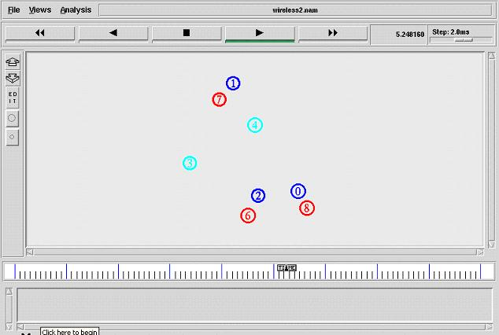

Tcl script to set nodes’ initial and destination position randomly
Destination:
Number of nodes is fixed (8) in the program. Nodes are configured with specific parameters of a mobile wireless node. After creating the nam file and trace file, we set up topography object. set node_ ($i) [$ns node] is used to create the nodes. Initial location of the nodes is not fixed. X, Y coordinates are randomly selected and assigned to every node. Nodes are given mobility with fixed speed and random destination. Destination location will be changed time to time. Here we set the initial size for the every node by using initial_node_pos. AODV routing protocol is used here. $val(stop) specifies the end time of the simulation. Each group of nodes is given different color.
File name: “wireless3.tcl”
# Define options
set val(chan) Channel/WirelessChannel ;# channel type
set val(prop) Propagation/TwoRayGround ;# radio-propagation model
set val(netif) Phy/WirelessPhy ;# network interface type
set val(mac) Mac/802_11 ;# MAC type
set val(ifq) Queue/DropTail/PriQueue ;# interface queue type
set val(ll) LL ;# link layer type
set val(ant) Antenna/OmniAntenna ;# antenna model
set val(ifqlen) 50 ;# max packet in ifq
set val(nn) 8 ;# number of mobilenodes
set val(rp) AODV ;# routing protocol
set val(x) 500 ;# X dimension of topography
set val(y) 400 ;# Y dimension of topography
set val(stop) 10 ;# time of simulation end
#Creating simulation:
set ns [new Simulator]
#Creating nam and trace file:
set tracefd [open wireless3.tr w]
set namtrace [open wireless3.nam w]
$ns trace-all $tracefd
$ns namtrace-all-wireless $namtrace $val(x) $val(y)
# set up topography object
set topo [new Topography]
$topo load_flatgrid $val(x) $val(y)
set god_ [create-god $val(nn)]
# configure the nodes
$ns node-config -adhocRouting $val(rp) \
-llType $val(ll) \
-macType $val(mac) \
-ifqType $val(ifq) \
-ifqLen $val(ifqlen) \
-antType $val(ant) \
-propType $val(prop) \
-phyType $val(netif) \
-channelType $val(chan) \
-topoInstance $topo \
-agentTrace ON \
-routerTrace ON \
-macTrace OFF \
-movementTrace ON
## Creating node objects..
for {set i 0} {$i < 3 } { incr i } {
set node_($i) [$ns node]
}
for {set i 0} {$i < 3 } {incr i } {
$node_($i) color blue
$ns at 0.0 "$node_($i) color blue"
}
for {set i 3} {$i < 6 } { incr i } {
set node_($i) [$ns node]
}
for {set i 3} {$i < 6 } {incr i } {
$node_($i) color cyan
$ns at 1.0 "$node_($i) color cyan"
}
for {set i 6} {$i < 8 } { incr i } {
set node_($i) [$ns node]
}
for {set i 5} {$i < 8 } {incr i } {
$node_($i) color red
$ns at 2.0 "$node_($i) color red"
}
## Provide initial location of mobilenodes..
for {set i 0} {$i < $val(nn) } { incr i } {
set xx [expr rand()*500]
set yy [expr rand()*400]
$node_($i) set X_ $xx
$node_($i) set Y_ $yy
}
# Define node initial position in nam
for {set i 0} {$i < $val(nn)} { incr i } {
# 30 defines the node size for nam
$ns initial_node_pos $node_($i) 30
}
# Telling nodes when the simulation ends
for {set i 0} {$i < $val(nn) } { incr i } {
$ns at $val(stop) "$node_($i) reset";
}
# dynamic destination setting procedure..
$ns at 0.0 "destination"
proc destination {} {
global ns val node_
set time 1.0
set now [$ns now]
for {set i 0} {$i<$val(nn)} {incr i} {
set xx [expr rand()*500]
set yy [expr rand()*400]
$ns at $now "$node_($i) setdest $xx $yy 10.0"
}
$ns at [expr $now+$time] "destination"
}
#stop procedure..
$ns at $val(stop) "stop"
proc stop {} {
global ns tracefd namtrace
$ns flush-trace
close $tracefd
close $namtrace
exec nam wireless3.nam &
}
$ns run

# How to run the program:
$ns wireless3.tcl
#snapshot of the program:
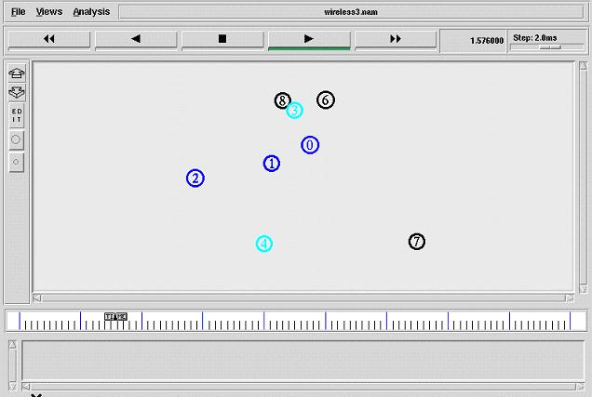

Tcl script to draw the graph and set x and y coordinates randomly.
Description:
X, Y coordinates for the graph is generated randomly and put it in a trace file. The trace file is given as input file to xgraph to plot the graph.
File name: “graph1.tcl”
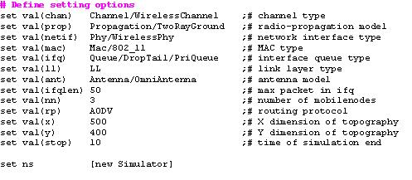
# Creating simulation
set ns [new Simulator]
#Creating nam and trace file
set tracefd [open Graph1.tr w]
set namtrace [open Graph1.nam w]
$ns trace-all $tracefd
$ns namtrace-all-wireless $namtrace $val(x) $val(y)
# set up topography object
set topo [new Topography]
$topo load_flatgrid $val(x) $val(y)
set god_ [create-god $val(nn)]
# configure the nodes
$ns node-config -adhocRouting $val(rp) \
-llType $val(ll) \
-macType $val(mac) \
-ifqType $val(ifq) \
-ifqLen $val(ifqlen) \
-antType $val(ant) \
-propType $val(prop) \
-phyType $val(netif) \
-channelType $val(chan) \
-topoInstance $topo \
-agentTrace ON \
-routerTrace ON \
-macTrace OFF \
-movementTrace ON
## Creating node objects..
for {set i 0} {$i < $val(nn) } { incr i } {
set node_($i) [$ns node]
}
for {set i 0} {$i < $val(nn) } {incr i } {
$node_($i) color black
$ns at 0.0 "$node_($i) color black"
}
# Provide initial location of mobilenodes
$node_(0) set X_ 50.0
$node_(0) set Y_ 50.0
$node_(0) set Z_ 0.0
$node_(1) set X_ 200.0
$node_(1) set Y_ 250.0
$node_(1) set Z_ 0.0
$node_(2) set X_ 300.0
$node_(2) set Y_ 300.0
$node_(2) set Z_ 0.0
# Define node initial position in nam
for {set i 0} {$i < $val(nn)} { incr i } {
# 30 defines the node size for nam
$ns initial_node_pos $node_($i) 30
}
# Telling nodes when the simulation ends
for {set i 0} {$i < $val(nn) } { incr i } {
$ns at $val(stop) "$node_($i) reset";
}
# ending nam and the simulation
$ns at $val(stop) "$ns nam-end-wireless $val(stop)"
$ns at $val(stop) "stop"
$ns at 10.01 "puts \"end simulation\" ; $ns halt"
#Graph procedure..
$ns at 1.0 "Graph"
set g [open graph.tr w]
proc Graph {} {
global ns g
set time 1.0
set now [$ns now]
puts $g "[expr rand()*8] [expr rand()*6]"
$ns at [expr $now+$time] "Graph"
}
#Stop proceture
proc stop {} {
global ns tracefd namtrace
$ns flush-trace
close $tracefd
close $namtrace
exec xgraph -M -bb -geometry 700X800 graph.tr &
exec nam Graph1.nam &
exit 0
}
$ns run
# How to run the program
$ns Graph1.tcl
# snapshot of the program output
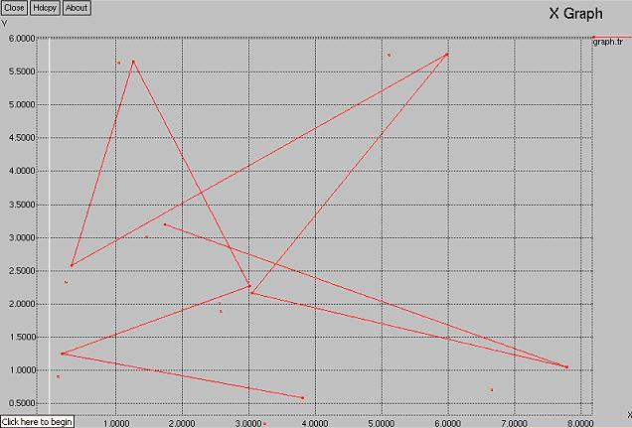

Tcl script to generate graph taking two parameter files as input
Description:
X, Y coordinates points for the graph is generated randomly and put it in a trace file. The trace file is given as input file to xgraph to plot the graph. Here two trace files are plotted in the single graph. Point of each trace file will be differentiated in color.
File name: “graph2.tcl”
# Creating simulation
set ns [new Simulator]
#Creating nam and trace file
set tracefd [open Graph2.tr w]
set namtrace [open Graph2.nam w]
$ns trace-all $tracefd
$ns namtrace-all-wireless $namtrace $val(x) $val(y)
# set up topography object
set topo [new Topography]
$topo load_flatgrid $val(x) $val(y)
set god_ [create-god $val(nn)]
# configure the nodes
$ns node-config -adhocRouting $val(rp) \
-llType $val(ll) \
-macType $val(mac) \
-ifqType $val(ifq) \
-ifqLen $val(ifqlen) \
-antType $val(ant) \
-propType $val(prop) \
-phyType $val(netif) \
-channelType $val(chan) \
-topoInstance $topo \
-agentTrace ON \
-routerTrace ON \
-macTrace OFF \
-movementTrace ON
## Creating node objects..
for {set i 0} {$i < $val(nn) } { incr i } {
set node_($i) [$ns node]
}
for {set i 0} {$i < $val(nn) } {incr i } {
$node_($i) color black
$ns at 0.0 "$node_($i) color black"
}
# Provide initial location of mobilenodes
$node_(0) set X_ 50.0
$node_(0) set Y_ 50.0
$node_(0) set Z_ 0.0
$node_(1) set X_ 200.0
$node_(1) set Y_ 250.0
$node_(1) set Z_ 0.0
$node_(2) set X_ 300.0
$node_(2) set Y_ 300.0
$node_(2) set Z_ 0.0
# Define node initial position in nam
for {set i 0} {$i < $val(nn)} { incr i } {
# 30 defines the node size for nam
$ns initial_node_pos $node_($i) 30
}
# Telling nodes when the simulation ends
for {set i 0} {$i < $val(nn) } { incr i } {
$ns at $val(stop) "$node_($i) reset";
}
# ending nam and the simulation
$ns at $val(stop) "$ns nam-end-wireless $val(stop)"
$ns at $val(stop) "stop"
$ns at 10.01 "puts \"end simulation\" ; $ns halt"
#Graph procedure..
#procedure..
$ns at 1.0 "Graph"
set g [open graph.tr w]
set g1 [open graph1.tr w]
proc Graph {} {
global ns g g1
set time 1.0
set now [$ns now]
puts $g "[expr rand()*8] [expr rand()*6]"
puts $g1 "[expr rand()*8] [expr rand()*6]"
$ns at [expr $now+$time] "Graph"
}
#stop procedure:
proc stop {} {
global ns tracefd namtrace
$ns flush-trace
close $tracefd
close $namtrace
exec xgraph -P -bb -geometry 700X800 graph.tr graph1.tr &
exec nam Graph2.nam &
exit 0
}
$ns run
# How to run the program
$ns Graph2.tcl
# snapshot of the program output
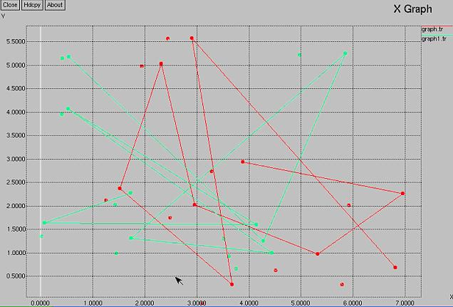

Tcl script to generate graph taking more than two parameter files as input
Description:
X, Y coordinates points for more than one graph is generated randomly using recursive procedure and put it in the trace files. All the trace files are given as input file to xgraph.
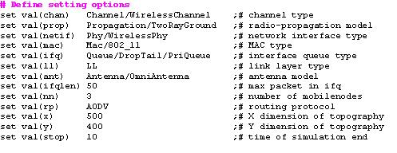
File name: “graph3.tcl”
# Creating simulation
set ns [new Simulator]
#Creating nam and trace file
set tracefd [open Graph3.tr w]
set namtrace [open Graph3.nam w]
$ns trace-all $tracefd
$ns namtrace-all-wireless $namtrace $val(x) $val(y)
# set up topography object
set topo [new Topography]
$topo load_flatgrid $val(x) $val(y)
set god_ [create-god $val(nn)]

# configure the nodes
$ns node-config -adhocRouting $val(rp) \
-llType $val(ll) \
-macType $val(mac) \
-ifqType $val(ifq) \
-ifqLen $val(ifqlen) \
-antType $val(ant) \
-propType $val(prop) \
-phyType $val(netif) \
-channelType $val(chan) \
-topoInstance $topo \
-agentTrace ON \
-routerTrace ON \
-macTrace OFF \
-movementTrace ON
# Creating node objects..
for {set i 0} {$i < $val(nn) } { incr i } {
set node_($i) [$ns node]
}
for {set i 0} {$i < $val(nn) } {incr i } {
$node_($i) color black
$ns at 0.0 "$node_($i) color black"
}
# Provide initial location of mobilenodes
$node_(0) set X_ 50.0
$node_(0) set Y_ 50.0
$node_(0) set Z_ 0.0
$node_(1) set X_ 200.0
$node_(1) set Y_ 250.0
$node_(1) set Z_ 0.0
$node_(2) set X_ 300.0
$node_(2) set Y_ 300.0
$node_(2) set Z_ 0.0
# Define node initial position in nam
for {set i 0} {$i < $val(nn)} { incr i } {
# 30 defines the node size for nam
$ns initial_node_pos $node_($i) 30
}
# Telling nodes when the simulation ends
for {set i 0} {$i < $val(nn) } { incr i } {
$ns at $val(stop) "$node_($i) reset";
}
# ending nam and the simulation
$ns at $val(stop) "$ns nam-end-wireless $val(stop)"
$ns at $val(stop) "stop"
$ns at 10.01 "puts \"end simulation\" ; $ns halt"
#Graph procedure..
$ns at 1.0 "Graph"
set g [open graph.tr w]
set g1 [open graph1.tr w]
set g2 [open graph2.tr w]
proc Graph {} {
global ns g g1
set time 1.0
set now [$ns now]
puts $g "[expr rand()*8] [expr rand()*6]"
puts $g1 "[expr rand()*8] [expr rand()*6]"
puts $g2 "[expr rand()*8] [expr rand()*6]"
$ns at [expr $now+$time] "Graph"
}
#Stop proceture
proc stop {} {
global ns tracefd namtrace
$ns flush-trace
close $tracefd
close $namtrace
exec xgraph -M -bb -geometry 700X800 graph.tr graph1.tr graph2.tr &
exec nam Graph3.nam &
exit 0
}
$ns run

# How to run the program
$ns Graph3.tcl
# snapshot of the program output

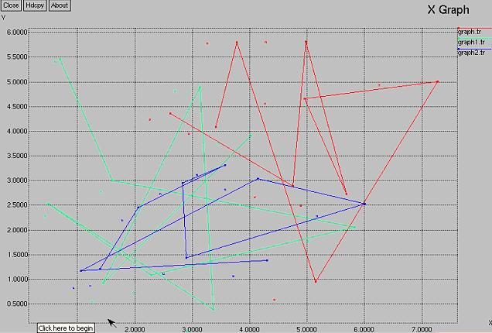

Otcl coding to create classes and objects.
Description:
An OTcl script that defines two object classes, "teacher" and "student", where "Student" is the child class of "teacher", and a member function called "greet" for each class. After the class definitions, each object instance is declared, the "subject" variable of each instance is set to maths for teacher and name for student and the "greet" member function of each object instance is called. The keyword Class is to create an object class and instproc is to define a member function to an object class. Class inheritance is specified using the keyword -superclass. In defining member functions, $self acts same as the "this" pointer in C++, and instvar checks if the following variable name is already declared in its class or in its superclass. Finally, to create an object instance, the keyword new is used.
File name: “Otcl.tcl”
# Add a member function call”greet”
Class Teacher
Teacher instproc init {subject} {
$self instvar subject_
set subject_ $subject
}
# Creating a child class of teacher and student
Teacher instproc greet {} {
$self instvar subject_
puts "$subject_ teacher ask
which subject u studied?"
}
#creating a teacher and student object
Class student -superclass Teacher
student instproc greet {} {
$self instvar subject_
puts "$subject_ say
i studied maths"
}
# calling member function “greet” of each node
set a [new Teacher maths]
set b [new student Jey]
$a greet
$b greet
#how to run
$ns <filename>.tcl
# output snapshot

